This diagram shows the interactions between the various components in the **drug sales forecasting system** powered by **Generative AI (GAI)** and **Evergrowth’s AI-driven platform**.

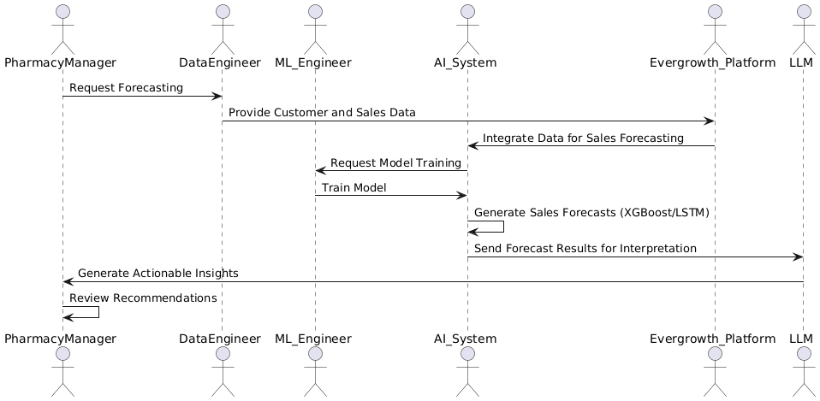

**Figure 1. PlantUML Diagram with Evergrowth Integration**

1. **Pharmacy Manager**:
   * **Requests Forecasting**: The **Pharmacy Manager** initiates the forecasting process, requesting predictions for drug sales.
   * **Reviews Recommendations**: Once the forecast and actionable insights are generated, the **Pharmacy Manager** reviews the recommendations provided by the system.
2. **Data Engineer**:
   * **Provides Customer and Sales Data**: The **Data Engineer** prepares and provides the necessary customer and sales data for training the forecasting model.
3. **ML Engineer**:
   * **Requests Model Training**: The **ML Engineer** requests the **AI System** to start the model training process.
   * **Trains Model**: They train the **XGBoost** and **LSTM** models on the provided data.
4. **AI System**:
   * **Generates Sales Forecasts**: The **AI System** generates forecasts for drug sales using the **XGBoost** and **LSTM** models.
   * **Sends Forecast Results for Interpretation**: Once forecasts are made, the **AI System** sends the results to the **LLM** for further interpretation.
5. **Evergrowth Platform**:
   * **Integrates Data for Sales Forecasting**: **Evergrowth Platform** integrates customer data and sales information, enhancing the forecasting accuracy by providing detailed insights from its platform.
6. **LLM (Large Language Model)**:
   * **Generates Actionable Insights**: The **LLM** interprets the sales forecasts and generates human-readable recommendations for the **Pharmacy Manager** to act on.

**Workflow:**

1. The **Pharmacy Manager** requests the **AI System** to forecast drug sales.
2. The **Data Engineer** provides customer and sales data to the **AI System**.
3. The **ML Engineer** requests model training and trains the **XGBoost/LSTM** models.
4. The **AI System** generates the forecasts and sends them for interpretation to the **LLM**.
5. The **LLM** interprets the forecast results and generates actionable insights, which are then reviewed by the **Pharmacy Manager** to optimize stock levels and inventory management.